Dynamic Connection Management System for Optical Networks: Applicability in a TINA environment
Sten Hubendick, Leif Byström

Telia Research AB, Network Services
S-123 86 Farsta, Sweden
{sten.a.hubendick,leif.j.bystrom}@telia.se

Abstract
Concepts and design for management of a re-configurable WDM network using optical cross-connects and carrying IP-traffic is implemented in the Winchester network and evaluated from a TINA perspective. Differences and similarities between this proprietary architecture and TINA are discussed and the applicability of TINA in an IP/WDM network environment is discussed.

Introduction
A management system for fast provisioning and protection of optical connections has been developed and is described in this paper. Important issues concern distribution, scalability, platform-independence, and also approaches for integrating the optical layer and the IP layer. The technologies are complementary. A re-configurable WDM optical layer can be used for interconnecting IP routers. By manual or automatic reconfiguration of light-paths, it is possible to adapt the IP router topology to changing traffic patterns, thus gaining higher throughput and lower latency in the network [OPCN]. The objective is to describe how to integrate a high-performance IP/WDM intra-domain network into a global IP-based TINA Connectivity Layer Network (CLN) environment.
The Test Network
A field trial network, Winchester [THE4], has been set up in the Stockholm metropolitan area. This test network has four nodes, which are connected by fiber pairs, with a total fiber length of 120 km, see Figure 1. Each transmission section is configured as DWDM point to point links. In each node an optically interfaced electrical cross-connect (OiEXC) connects the optical signals between the WDM equipment and the router(s). Thus, a large degree of flexibility in logical network configuration and protection is possible. A network management system (NMS) is implemented, and different levels of distributed control are evaluated. The NMS is implemented using Java [SUN] and CORBA [OMG]. Figure 1 shows the network and application architecture, including the distributed environment (CORBA).

Network Services
Figure 1. The physical network with network elements and corresponding management applications. All agents communicate via a CORBA distributed platform.
The Network management system provides several types of services, some of which are:
Configuration and monitoring of network resources is the most basic service, enabling higher layer services.
Fast end to end path provisioning, where paths can have different priority, enabling cost-differentiation and preempt-ability of resources.
Protection and restoration of paths, which involves switching to already allocated protection paths or reconfiguration of a path in the event of a network failure.
Multicast services, which means that a flow can be split to any number of out-flows in a node, thus enabling e.g. bundled video distribution.

Network Manager
In the Winchester network, provisioned connections have one of three priorities: low, normal or protected. Low priority connections are preempt-able and will be able to use resources reserved for other purposes, i.e., if someone has reserved a resource then a low priority connection that allocates and starts using that resource will risk to loose it if the reserver acquires it. Protected connections reserve resources for recovery from connection failures. The connection and protection paths use diverse node and link resources to protect from network failures as far as possible. A normal connection has a guarantee to work as long as no failure occurs in its path.
The manager handles uni-directional connections. To choose connection route, either an automatic mode where input consists of beginning and end points or a manual mode that allows explicit routes to be specified can be used. The automatic mode uses Dijkstra’s shortest path algorithm for route calculation, with the constraint of using only available resources in the network. It is also possible to add other path constraints.
Protection against node failure, link failure and channel failure, is implemented. If a restoration attempt fails any possibly pre-empted connections will continue as soon as a cleaning process reverse the restoration attempt after the management system has become stable and no failure handling is going on.
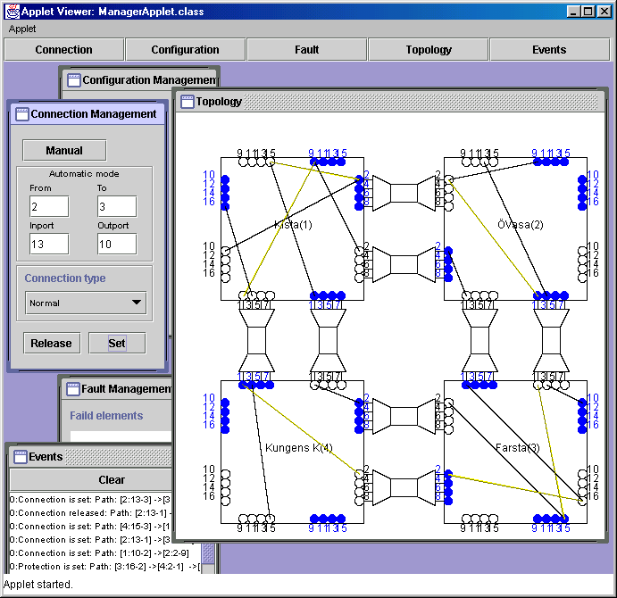
Figure 2. The User Interface for the NMS: shows the physical topology. In the main window, nodes with connecting fibres and WDM-channels associated with ports can be seen. Over this structure, paths are shown. Weak lines are reserved resources, black is connections
The user interface program, Figure 2, provides tools for configuration-, performance- and fault management. Resources and connections are chosen by pointing and clicking in a topology window that displays the different OiEXC’s, input and output ports.
To make a multicast connection the multicast tree has to be built with successive connection requests, explicit or automatic. The tree is therefore treated as several distinct connections.
Node element agents control and survey OiEXC operation (via a small hardware control application), and report faults. A central manager provides user operation and maintenance, keeps track of configurations and connections and restores failed connections. It performs this by delegating this responsibility to the distributed agents, which use signaling for network configuration changes.
This distributed architecture gives flexibility (addition of Java objects is simple, and CORBA provides flexibility in choice of programming language), robustness (agents can crash while the rest of the NMS still will work and provide state information to agents that restarts), and scalability (central agents can control separate parts of the network and together the whole of it).

Centralized versus Distributed Control in Winchester
One essential question is of how much of the management functionality can be distributed, i.e. delegated into the network itself. One difficulty lies in the fact that all ports in the Winchester OiEXC are non-terminating, and thus it is not possible to identify neighbor identities on a port level. Therefore the physical topology can not be deduced automatically. So there is a need for a configuration bootstrap. This is provided by the NMS central agent, see Figure 1. It contains the physical topology of the network, and distributes this information to all nodes. After this has taken place, any node agent can take the role of ‘network manager’, requesting paths through the network (source-routing). This capability would let a router request the local OiEXC to set up a path to a destination router. This means that when the physical topology has been distributed, all nodes can individually request paths through the network, without the central NMS. Thus, after the bootstrap it is possible for the network to behave as an autonomous system.

The Winchester Information Model
This section presents some of the more relevant information objects in the Winchester Information Model (WIM).
The WIM is built on basic objects representing a specific WDM layer network with OEXC capabilities. The only objects representing physical entities are the OEXCUnit object, the InputPort object and the OutputPort object. The remaining objects are representations for abstract entities required for managing various networks services.

OEXC Objects
The OEXCUnit object represents the cross-point switch element. It contains InputPorts and OutputPorts objects, representing optical input ports and output ports. Each object contains parameters representing the state of the managed entities. See Figure 3.
Figure 3. The Opto-electrical Cross Connect Managed objects. OEXCUnit contains parameters relating to the Opto-electrical Cross-connect as well as the objects InputPort and OutputPort. The InputPort and OutputPort objects represent optical input ports and output ports.

Connection Objects
The Path object contains information relating to the network lightpath. This includes all the nodes that the path passes through, and which ports at each node are involved. For uni-directional connections one path is used. For bi-directional connections, two paths are allocated, one in each direction. For multicast connections, the multicast tree has to be built with several paths through the network, one path for each uni-directional connection. See Figure 4.
Figure 4. The Path object

Event Objects
The message passing system uses the LOSData object (Loss of Signal) and the OperatorMessage object. They both contain a DateTime object for timestamp purposes. Between the NE agents (NE agent to NE agent), the NMessage is used instead.

Interface Objects
Figure 5. Message handling between the NE agent and the NM is done with the OperatorMessage object. It contains a DateTIme object. The LOSData object is used for handling ‘loss of optical signal’ information. The NMessage object is used for inter NE agent information distribution.
All communication between NE agents and NM is done through CORBA interfaces, see Figure 6. The NEAgentInterface is the inteface provided by the Network Element agent. It provides functions for registration, eventhandling, configuration and monitoring. The Callback interface is used by the NE agent to notify the NM of events that needs its attention. The NMAgentInterface is provided by the Network Manager and contains functions for registration of NE agents, connection management and event management. The NNI interface is published by the NE agents and is used for intra NE agent distribution of management information.
Figure 6. There are four CORBA Interfaces: The NEAgentInterface and NNI interface are published by the Network Element Agent. The NMAgentInterface and the Callback interface are published by the Network Manager Agent.

Generic representation of both IP and WDM network resources
A WDM network is connection-oriented, therefore the mapping between Winchester Information Model (WIM) and TINA NRIM is very straightforward. This paper has not the intention of describing a comprehensive mapping schema between those two models, therefore only some of the information objects in the Winchester Information Model (WIM) are presented.
This section give a proposal on how to use the TINA NRIM 4.0 [RIM] and the Telia IPCM RfP submission [TIPCM] for modeling the Winchester WDM resources. The purpose behind this approach is to enable for any client to use generic notions when describing what kind of server network resources that are required. This is done by allowing any client to know and use the object Capabilities of the connectivity service without knowing the transport technology.
The OEXCUnit is a physical network device. It is able of cross-connecting lightpaths in an optical WDM network. It is the active node element which facilitates a dynamic optical layer. The OEXCUnit class inherits from the TINA NRIM 4.0 ManagedNetworkElement class, see Figure 7. A ManagedNetworkElement is a network element that contains a more detailed representation of the set of network level resources that are supported by the actual device.
Figure 7. The OEXCUnit object inherits from the ManagedNetworkElement object.
The Trail object replaces the Winchester Path object when a TINA environment is introduced. See Figure 8.
Thus, the layer network delivery object from the WDM network is a trail. This object is on a generic TINA CLN level represented as a Network Flow [TIPCM]. The Network Flow (NF) object is used by the IP layer to link together IP nodes. The difference between the approach above and TINA NRIM is that the client IP layer are using a generic object, the NF, to change or extend its topology. The topology extension is done by adding a link between IP nodes.
Figure 8. The Trail object in NRIM replaces the Path object.

Applicability of a TINA Connectivity Provider Environment in Winchester
This section gives a proposal on how to use a TINA Connectivity Provider domain on top of a Winchester network. In this paper, the scope of the TINA CLN is restricted to represent a global and public internetworking end-to-end transport network. Since IP is the ubiquitous public end-to-end network protocol, and following the restrictions above, IP is therefore within this paper considered to fully satisfy the requirements of being the only terminating protocol of the TINA CLN.
The WIM can be seen as a very simplified version of a connection-oriented TINA NRIM. Also, the internal representation of network/connectivity objects on a sub-network level and lower is different from the TINA-notion. However, this is not considered a problem, since the purpose of this paper is to show the applicability of using the generic TINA connectivity layer network (TINA CLN) concept when representing WDM network resources. The purpose is also to describe how those generic resources should be used by a client IP layer.
By combining a generic TINA end-to-end view on network resources with an IP/WDM network architecture, the following criteria can be achieved:
- Existence of an IP intra-domain network served by an underlying server network layer with the following characteristics:
- WDM based
- Dynamic connection management
- high through-put
- protection and restoration services
- Representation of an underlying connection-oriented WDM resource information model with a generic end-to-end network resource information model, e.g. TINA NRIM.
- The unifying TINA connectivity layer network in a public and global perspective (i.e. Internet) is the IP technology.
- Common notion usage of network resources between different administrative domains which facilitates a common framework for interconnectivity between operators.
- Using the TINA environment for the Winchester network makes it possible to reach a consistent connectivity service mapping schema between IP and WDM and thus enabling federation between networks, either on IP or optical level.
- Formalized WDM based SLA templates towards IP layer or other WDM administrative domains.
- Formalized capability specifications for WDM-based optical networks in general and for the Winchester network in specific. (E.g. Winchester 3R, switch speed, fast protection services)
- The IP layer is allowed to manage underlying server network layer resources in a generic manner, resulting in the following interoperability benefit:
- Enabler of federation between different administrative IP domains, with traffic conditioning agreements that guarantees more than best-effort and security, e.g. bandwidth guarantees, delay, delay jitter, packet loss etc. This is done by applying a generic information model of network resources used for information exchange between administrative domains. The generic information model can also be applied into management systems from different vendors. This implies also that the approach is an enabler for reaching standards on how inter-domain IP resources and their belonging SLA templates is agreed on between administrative domains.

Conclusion
Winchester is an up-and-running WDM transport network, with IP running on top of it. By incorporating it into a TINA environment, a consistent model for IP/WDM layer network inter-working can be achieved.
Combining the WDM high-performance capabilities with a TINA influenced management architecture enables an optimal WDM-based intra-domain network architecture, that is scalable and functional in a global, public and heterogeneous environment where IP is the common internetworking technology.

References
[OPCN] Biswanath Mukherjee, “Optical Communications Networks (WDM, Broadcast/Multicast, Wavelength-Routing)”, McGraw-Hill Companies, 1997.
[THE4] S. N. Larsson et al, ThE4, OFC 2000.S. N. Larsson et al, ThE4, OFC 2000.
[ECOC] S. Hubendick et al, 336, ECOC 2000
[RFC2702] D. Awduche et al, RFC-2702, Sep. 1999.
[MPLDS] D. Awduche et al.,”Multi-protocol lambda switching: Combining MPLS traffic engineering control with optical cross-connects”, Internet draft, Work in progress, October 1999.
[SUN] SUN Microsystems Inc, http://www.sun.com
[OMG] Object Management Group, http://www.omg.org
[RIM] Lyle Bertz and Raymond Reeves, “TINA Architecture Models: Resource Information Model”, v 4.0 Release 1.0, May 2000.
[TIPCM] Leif Bystrom et al, “Telia TINA-C IPCM Initial RfP Submission: A Framework for Connectivity Service Delivery Process (Client/Server / Federation)”, March 2000.

