From a Single Universe to Multiple Parallel Universes
– TINA in the age of telecom service Big Bang -
Takeo Hamada, Mitsuhiro Nakamura*

Fujitsu Laboratories of America, * Fujitsu Ltd.
595 Lawrence Expway, Sunnyvale, CA 95085, USA
phone:+1 408-530-4575
fax:+1 408-530-4515
email: thamada@fla.fujitsu.com

Abstract
The telecommunication service is going under dramatic changes, which may be compared to a chaotic universe after the Big-Bang. Inspired by a cosmology theory called self-reproducing inflationary universe, we view that the impact of the internet was actually a Big-Bang, which initiated expansion of telecommunication service space in an unprecedented speed.
The telecommunication service space will branch out into multiple universes, and the chaotic state we observe today will subside, becoming a new generation of cosmos of its own. This paper analyzes outcome and assumptions of TINA in this light, examines its validity as a principle for the forthcoming cosmos. Positive prospects are found for TINA as a common resource and service management framework of the public packet network infrastructure, which are elaborated in the proposals made by the authors for open QoS pricing and ConS-IPCM specification.

Introduction
Reflecting back the 10 years of TINA-C, we can not help but being amazed at how far the telecommunication landscape has changed during the period. At the dawn of the 21st century, it is tempting to ponder upon the role TINA played in the transition, and the role it may play in the future.
It is probably a consensus now that the internet is one of the most significant event in the history of the telecommunication, and as some suggests it, it may be only at the beginning. The full extent of business and social changes the internet will bring about is still difficult to measure, but it seems certain that the world will become an increasingly border-less and distance-less society.

The internet “Big-Bang”
One popular view is that the internet started with a “Big-Bang”, which unleashed an entirely new universe of service. It is a constantly evolving chaos, with which many old barriers in telecommunication service have been either broken or significantly weakened. Fueled by capital investment from the rising stock market, an entirely new set of carriers and vendors have emerged. At moment, it seems that the prospect for growth is seemingly unlimited: the internet traffic doubles every 90 days [1]. In an analogy, the internet is a rapidly expanding sphere of universe, which has set huge business and financial opportunities free.
Figure 1 Internet Growth Projection ([2])
Figuer 1 shows explosive growth of the internet, both in terms of revenue and traffic volume. The projection [2] shows the total internet revenue, excluding application services, can reach as much as 140.7 billion dollars by year 2007. The total internet traffic during the same period is projected to reach 15.6 Tbps.
The speed of evolution and growth of the internet is unusual, giving an impression that it is a chaos. Would it be possible, however, that the current state of chaos continue, or would it turn into a cosmos, as it seems to have happened eons ago in our universe? Or perhaps, would a new cosmos be created out of the current chaos, like the chaotic internet broke out of the more quiet and orderly world of PSTN service universe?

The internet service space expansion
The internet not only is expanding in its volume, but is also expanding in its service space. Since the appearance of its first “killer-app” World Wide Web in 1995, it seems we are entering the second phase of its evolution.
The internet service space expands both in terms of service variety and in dollar amount, though its doubling speed may be slower than that of the traffic volume. For example, we have seen in the past years emergence of new service types such as Portal service, ASP, B-to-B and B-to-C E-commerce, and appearance of Content Delivery Network (CDN), responding to the internet traffic demand which is becoming increasingly A/V stream oriented.
Figure 2 Internet Service Space Expansion
Each service space tends to start as an addition on the periphery to an existing service space, which may eventually become a more integrated part of the internet. For example, many of emerging internet service varieties are Web-based, an indication that the internet service space is evolving upward, feeding on top of the results of preceding evolution steps, extending its service (and service management) food chain. An outcome of this evolution is that the internet is turning itself into a virtual networked server [3].
Although we may be only at the second stage of its expansion, let us assume that the current speed of service space expansion continues, assuming further that a new echelon of services springs up every 5 years – an aeon in the internet time.

Telecom service space and self-reproducing cosmos
There is a striking analogy between the evolution of telecom service space (including the internet) and a cosmology theory on self-reproducing cosmos. On a philosophical side of the theory, the universe continuously rejuvenate itself, by branching out an “inflationary bubble”, which eventually blows up to become a full scale universe.
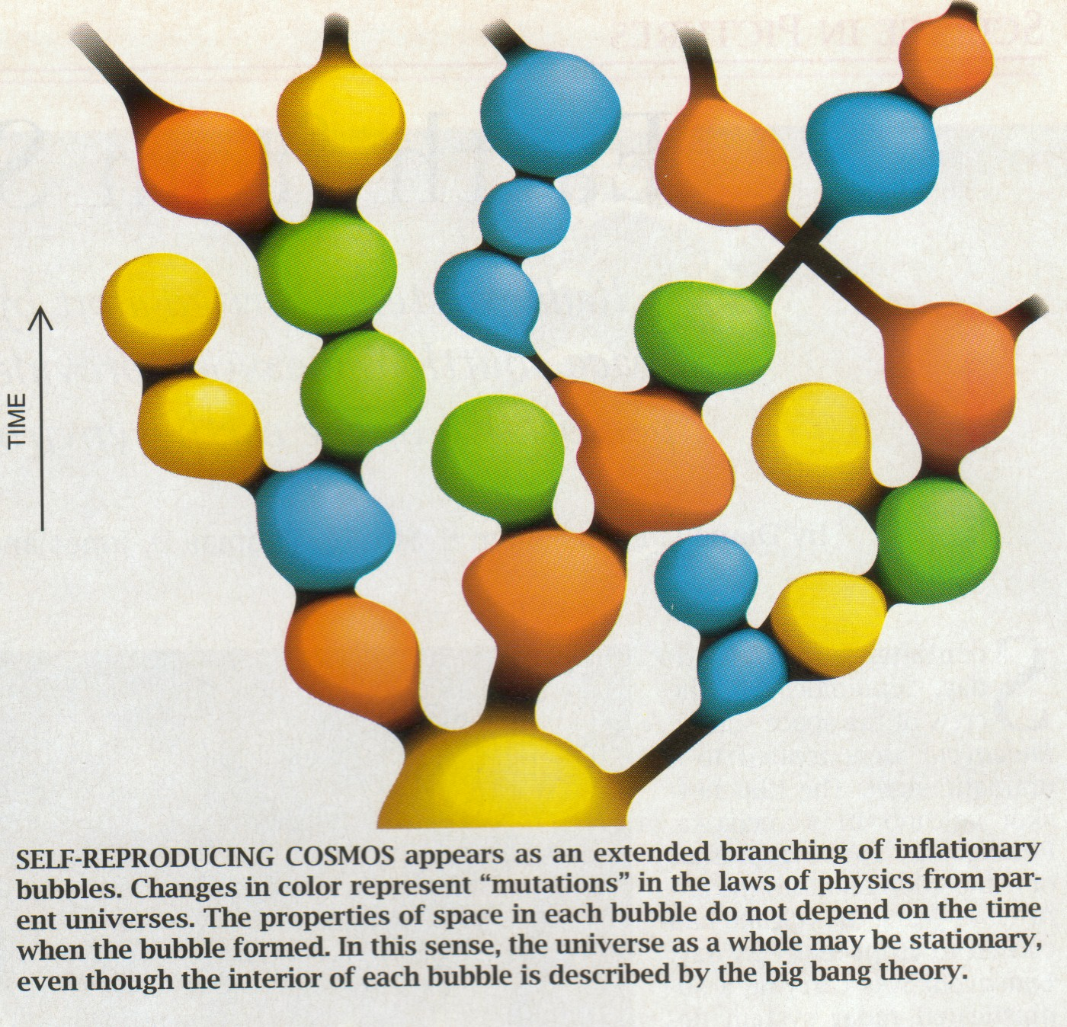
Figure 3 Self-reproducing Cosmos ([4])
The theory [4], although it is still highly speculative, suggests that each universe grows out of a tiny seedling of “inflationary bubble”, which explodes with a Big-Bang to become a full-scale universe, with each universe may have different physical laws from each other.
An obvious similarity between Figure 2 and 3 runs rather deep into the nature of the process. Accepting that the internet is a Big-Bang, a new chaotic universe is created out of an old cosmos, which will eventually branching out into a newer generation of universes.
Cosmos and chaos are two phases of the universe, where different physical laws dominate. After the Big-Bang, a part of the old universe turned into chaos, where existing order in the old universe was either not inherited, or largely disregarded. When the chaos subsides, a new set of order emerges, and another cosmos re-appears. The process repeats itself with a new Big-Bang.
The similarity between the telecom world and the cosmic world can be highlighted as follows:
- Big-Bang: the universe starts rapid expansion with a singular event .
- Early phase: succession of important events occur in a very short time period, forming an early structure of the universe. Things are chaotic as many things are subject to change, light (large infusion of capital fund) dominates the field. Early years of telephone systems and current status of the internet may be in this phase.
- Matured phase: large scale structure is fully developed, and the things are fairly stable so that the universe looks almost static.
An observation is that the universe does not transform itself from one cosmos to another cosmos, presumably prevented by its own physical laws. The self-reproducing cosmos theory seems to suggest that the chaotic disruption has to be a part of the process, for a new cosmos to be born and to grow within.
What happens to the old cosmos is also interesting. It does not change, or it may even keep its own course of development, but it simply becomes irrelevant to the development of the new universe.

TINA as a new cosmic principle
TINA is, in essence, a cosmic principle. Although it is a human design, TINA was designed to create a new order for the telecommunication service space. TINA was to bring about competition in an orderly manner, which is dictated by its business model and its associated set of reference points. In the following part of this section, we examine important features of TINA as a new cosmic principle.

End-to-end connection management for stream delivery
Connection graph (and Service Session Graph as its service layer extension) and stream interface are perhaps the most original technical contributions by TINA. As a conceptual framework, they can potentially offer an ideal tool for broadband multimedia delivery, e.g. as it is currently becoming a hot issue in Content Delivery Networks.
The potential, however, seems to have been largely ignored, due probably at least to two reasons. The first and obvious reason is that original TINA specifications had quality issues, which might have discouraged serious deployment efforts. Later efforts in OMG [5] and Parlay [6] have, in some sense, remedied the misgivings of the original TINA specifications, but it lost some scope during the process.
The second reason is the timing. Neither the old telecom cosmos nor the initial narrow-band internet could make use of the TINA connection management concept.

Session and QoS guarantee
Session is one of seven OSI layers, and is by no means TINA’s invention. TINA is, however, perhaps rather unique in using the concept consistently throughout its architecture and reference points. Session indeed provides a very fine vehicle as an effective scope for SLA and its associated service management functions.
In the internet, however, there is no universal session layer: definition of a session depends on applications. For example, an ftp session may consist of a few transactions of file transfer. An e-mail session is actually an SMTP transaction between a mail server and a client. It can be said that the TINA session has more in common with circuit-switched, connection-oriented PSTN session, and it is likely to be an overkill for short transactions of connection-less services.
In the new cosmos, end-users are connected to the virtual network server through always-on, broadband IP access [3]. In this network environment, these short-transaction connection-less services are to be a part of a fixed-priced package, and they are not going to be individually accounted. Connection-oriented services with solid QoS guarantee such as B-to-B VPN service will be accounted separately, and is therefore more amenable to TINA style session structure.

Network intelligence
A proposal called Stupid Network [7] advocated that network intelligence is harmful, and a simple, stupid network, which only offers high-speed pipes is better. Although there are some good points in its argument, the seeming conclusion could have been misunderstood by some audience. First, the argument was particularly pointed toward IN, not network intelligence in general. The thesis may be summarized that network intelligence has better to be taken off from the control plane.
Second, it may not be incorrect, but it may be at least inaccurate to identify the stupid network with the internet. In the beginning, the internet may have looked like a stupid network, when chaos was more dominant than cosmos. As time goes by, however, it has become more popular to add intelligence to the network, in particular in the management plane, as they are exemplified by Policy-Based Management standards activities at IETF and DMTF.
Although TINA has received initiatives from IN community inheriting a few key concepts, it probably has no more to do with IN than CORBA has to do with SS7. The TINA service paradigm, as it is exemplified by its Business Model, considerably differs from that of IN. As a matter of fact, TINA-IN interworking unit (IWU) has been proposed and even standardized [8], but it is difficult to use in practice, as it is forced to provide awkward service offerings. In short, we think that the traditional IN, a separate service circuit maintained by the network provider, will mostly remain confined in the old telecom cosmos, and may not extend to the new cosmos.
In the new cosmos, the service space will be filled with specialized network servers [3], which are accessed by standard application protocols such as HTTP and WAP. Much of IN service features will be subsumed into those severs with probably a twist toward narrow band and voice, e.g. WAP and voice portal.

Integrated control and management
Old cosmos telecommunication networks, in particular PSTN, has maintained clear separation of control, management, and data (voice) planes, so much so that they have been provided through separate circuits and protocols. Although this separation has contributed to the high reliability and universal availability of PSTN services, it also contributed to the high-cost structure of old cosmos telecommunication service space.
The Big-Bang and the resultant chaos essentially brought this separation down. In the internet, all the three planes are realized on the same ubiquitous IP layer, and distinctions are made only through application layer protocol header, leading to simpler deployment and configuration of the network.
In the new cosmos, availability of ubiquitous IP layer is an underlying assumption, therefore dedicated plane specific networks such as SS7 will all but disappear. On the other hand, management plane needs to remain, and will evolve into a programmable network, where service and resource provisioning needs to handle complex data structures, which are not necessarily suited for IP control plane protocols such as RSVP.
It is probably correct to say that TINA has a right idea from the beginning, in proposing that control and management are to be integrated using a common DPE substrate. In particular, observing the fact that CORBA evolved into the most popular platform for management systems in 1990s and wide popularity of Java in late 1990s, we tend to believe that there was (and still is) a chance of transition.

Business Model
Chaos means disorder. TINA business model is perhaps a unique invention of TINA, in the sense that it is an attempt to describe an ideal world observing a TINA cosmic principle. It dictates, in short, behavior of the business players and interactions between them at a high level through its descriptions of reference points.
Although the idea is good and benevolent, there have been obstacles in putting the idea into practice. Firstly, there seems to be little incentives for the players voluntarily adopt the business model. It is partly a chicken-and-egg issue, observing that there is no TINA “killer-app” in sight, which either assumes or requires TINA business model deployment.
Secondly, even if the players can move toward adoption of the business model, for it to realize its potential such as service management flow-through operation [9] much more sustained effort would be needed to enhance current reference points and relevant specifications.
Third factor may be the regulator. An original intention of TINA business model was that it enables to incorporate regulatory requirements into its reference points, thus making it possible to deal with regulatory changes quickly. In stark contrast to the old telecommunication cosmos, regulators seem willing to let free-wheel capitalism in the internet service space to run at least for a while. There is realistic prospect that some efforts, e.g. those at ICANN, can lead to a more regulatory environment, and growing need to fair and open handling of internet traffic would require more approaches from the regulatory side.

Section summary
The discussions in this section are not necessarily TINA critique, but they are intended to reveal mismatches between TINA and physical laws of the legacy telecom universe, and those of the internet universe. In particlar, we pointed out that TINA has brigher prospects in the connection management and integrated control and management, as we discussed in sections 5.1 and 5.4, respectively. It is to be noted that the phsical laws of the telecommunication service space have changed after the internet Big-Bang, which brought about a rather ironic situation: the farther from the old telecom cosmos laws (the bigger the mismatch) the better the prospects can be.

Fujitsu approach toward TINA
TINA can deliver viable technical elements for the new cosmic age, though they may not be exactly what was originally aimed at 10 years ago. It is our belief that TINA still offers significant value as a framework for service and resource management of networked servers.
In the emerging new cosmos, the internet is evolving into a packet-based public network infrastructure. In other words, it will require more accountable and reliable operation and management, at as high a standard as they are currently demanded on the PSTN. In particular, we believe that enhancing accountability of network services and transparency of pricing and billing operations are the important keys for TINA deployment
In the following part of this section, we illustrate results of the two works we performed at Fujitsu. The combined efforts should realize more open, transparent, as yet competitive environment in the forthcoming internet service space.

Open QoS Pricing
In the new telecommunication cosmos, bandwidth becomes a commodity, which can be bought and resold at a price dictated by the market. Bandwidth also provides the basic fluidity for the telecom service space, with which the players can exchange E-services.
Figure 4 NAgent Architecture
We proposed NAgent (Network Agent) [10], a TINA-based open QoS pricing market. In the current internet, much of topology (routing) and pricing information is hidden from the end user’s view, preventing the user from making intelligent decisions on possible routing options, and eventually SLA negotiation. In the proposed architecture, an intermediary called NAgent collects topology and pricing information from multiple network providers, in such a way that an end user is able to choose optimal paths among several candidate paths in the network.
There are mainly two reasons why NAgent will be needed. First one is that the routing information and optimal path selection will be complex, and the dynamic nature and sheer size of the information (the size of routing table) will make it exceedingly difficult for an end user to make an intelligent judgement. An NAgent will be able to offer information to the end user, in a form personalized and optimally suited for the end user application. The second reason is that NAgent is independent of network providers, enabling the NAgent to make more objective evaluation on performance of the network providers based on the market value.
Figure 5 NAgent Realization using TINA Business Model
Figure 4 illustrates architecture concept of NAgent. Its mapping on TINA Retailer is shown in Figure 5. In the figure, only components relevant to NAgent are given.

ConS-IPCM
In response to TINA IP Control and Management CFP, we submitted a contribution [10]. In the submission, we proposed to re-design the current ConS specification, in accordance with our view of TINA as a cosmic principle for the new telecom service space.
Figure 6 illustrates structure of the ConS-IPCM. It consists of four facets, namely SLA, Security, Monitoring, and Configuration, with each facet consisting of a few functionally cohesive interfaces.

Figure 6 Structrure of ConS-IPCM (Proposed)
The four facets facilitate the two players communicate with each other, in respective functional areas, realizing IP resource provisioning and monitoring functions, enabling more transparent, open QoS market as we proposed in the NAgent architecture.
Figure 7 End-to-end Flow-through Operation using ConS-IPCM
Figure 7 illustrates an end-to-end flow provisioning scenario using the ConS-IPCM reference point.
- A consumer requests delivery of on-line performance of Ballet.
- The SP contacts a 3Pty Provider, which is hosting the event.
- The SP talks to the CP through ConS-IPCM, to set up an IP connectivity honoring both the consumer’s and 3Pty’s service delivery requirements.
- The CP notifies the consumer that an IP VPN is set up between the consumer and the destination IP address.
- The CP notifies the 3Pty Provider that the IP VPN is provisioned.

Conclusion
In this paper, we analyzed the assumptions and outcome of TINA in the past years, and we found that TINA still offers good value to, and has an important prospect for redefining the role of telecommunication, and at the same time the role of the internet, as a more reliable and programmable public packet network infrastructure. Although the vision we presented in this paper were already part of the original TINA design, it has not been either sufficiently examined in previous analyses, or sufficient efforts has not been done to make concrete proposals to materialize the vision.
We believe the current activities at TINA IPCM WG is very important in bringing these visions closer to reality, and in giving TINA a renewed practical meaning based on urgent need for further development of the new telecommunication cosmos. Though the road to the new cosmos may be long and winding, TINA will continue to serve as a guiding light for generations of researches and engineers.

References
- G. Gilder, Telecosm: How Infinite Bandwidth Revolutionize the World, to be published in Sept. 2000.
- Morgan Stanley Dean Witter, “Uncorking the Internet Bottlenecks”, Industry Overview, June 5, 2000.
- A. Moridera, K. Murano, and Y. Mochida, “Network Paradigm of the 21st century and its key technologies”, ISS’2000, Birmingham, May 2000.
- A. Linde, “The Self-reproducing Inflationary Universe”, Scientific American, Nov. 1994.
- OMG, OMG A/V Stream Specification, Dec. 1999.
- Parlay, Parlay 2.0 Connection Management Specification, Jan. 2000.
- D. Isen, “Rise of the Stupid Network”, http://www.isen.com/stupid.html.
- TINA-C, IN Access to TINA Services and Connection Management, Oct. 1998.
- ACTS FlowThru project, http://www.cs.ucl.ac.uk/research/flowthru/
- M. Nakamura, M. Sato, T. Hamada, “NAgent: Towards a dawn of Open QoS Market”, ISS’2000, Birmingham, May 2000.
- Fujitsu submission for TINA-IPCM Work Group RFP, “A Framework for Connectivity Service Delivery Process”, Apr. 2000.

For example, IP will not be able to sustain the same level of QoS as circuit-switched networks, but in the long run it is probably irrelevant to the internet service space growth.
The original article [6] is not really anti-intelligence. It is actually an anti-voice-optimized PSTN. The original stupid network proposal resembles more to the PBM (Policy-Based-Management) empowered internet.
Distributed Management Task Force, http://www.dmtf.org
The Internet Corporation for Assigned Names and Numbers, http://www.icann.org

